Stage 1 Home Learning Grid

The activities highlighted in yellow are encouraged to be completed.
From this week, all activities will be posted on SeeSaw at 9am. Follow the timetable if you need a guide, but complete the activities when it suits you.

Remote Learning - Term 3, Week 5
 | Monday 9th of August | Tuesday 10th of August | Wednesday 11th of August | Thursday 12th of August | Friday 13th of August
Remember to read for at least 10 minutes each day  Morning | Log into Seesaw and comment on your teacher's good morning post. | Log into Seesaw and comment on your teacher's good morning post. | Log into Seesaw and comment on your teacher's good morning post. | Log into Seesaw and comment on your teacher's good morning post. | Log into Seesaw and comment on your teacher's good morning post.
 | Read a book in the PM e-Reader App. Alternatively, read a book of your own. If possible, record yourself and upload it onto SeeSaw. | Read a book in the PM e-Reader App. Alternatively, read a book of your own. If possible, record yourself and upload it onto SeeSaw. | Read a book in the PM e-Reader App. Alternatively, read a book of your own. If possible, record yourself and upload it onto SeeSaw. | Read a book in the PM e-Reader App. Alternatively, read a book of your own. If possible, record yourself and upload it onto SeeSaw. | Read a book in the PM e-Reader App. Alternatively, read a book of your own. If possible, record yourself and upload it onto SeeSaw.
 | Phonological Awareness  Focus -Revise ‘ay, ai a_e’  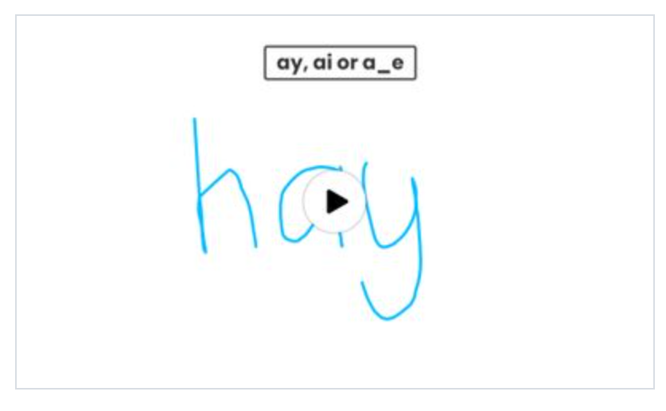 | Phonological Awareness  Focus - Long i  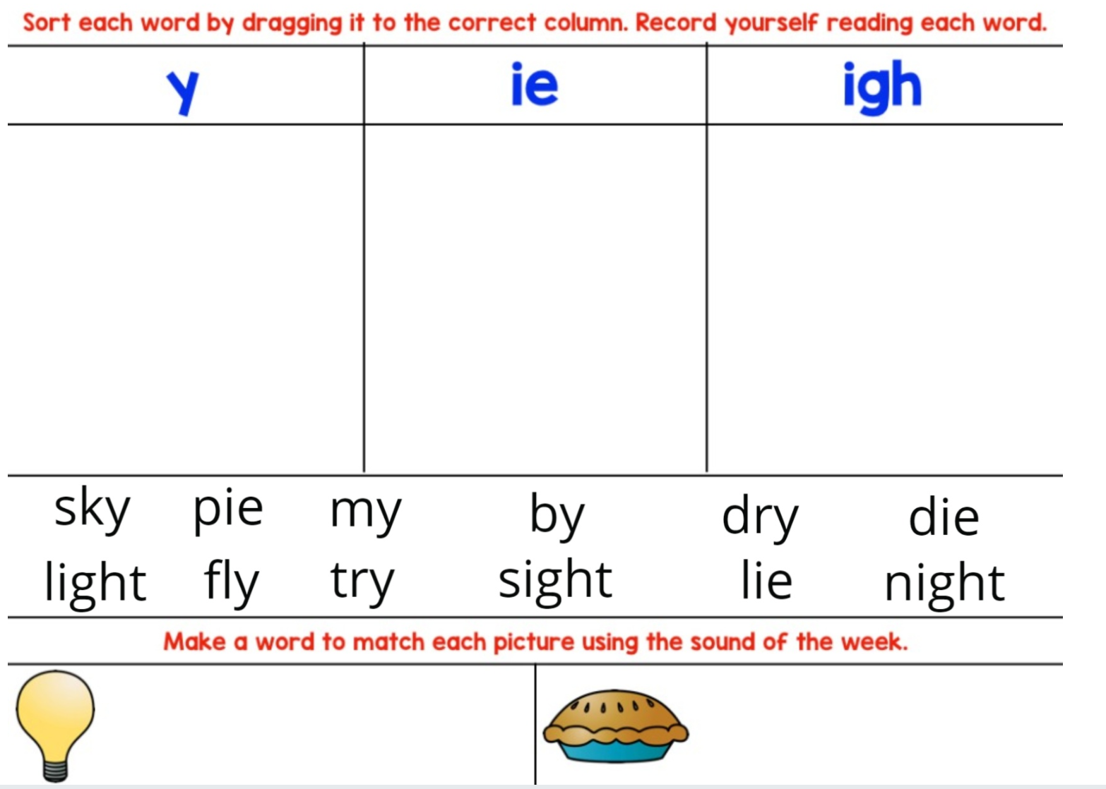 | Phonological Awareness  Focus- Rhyme  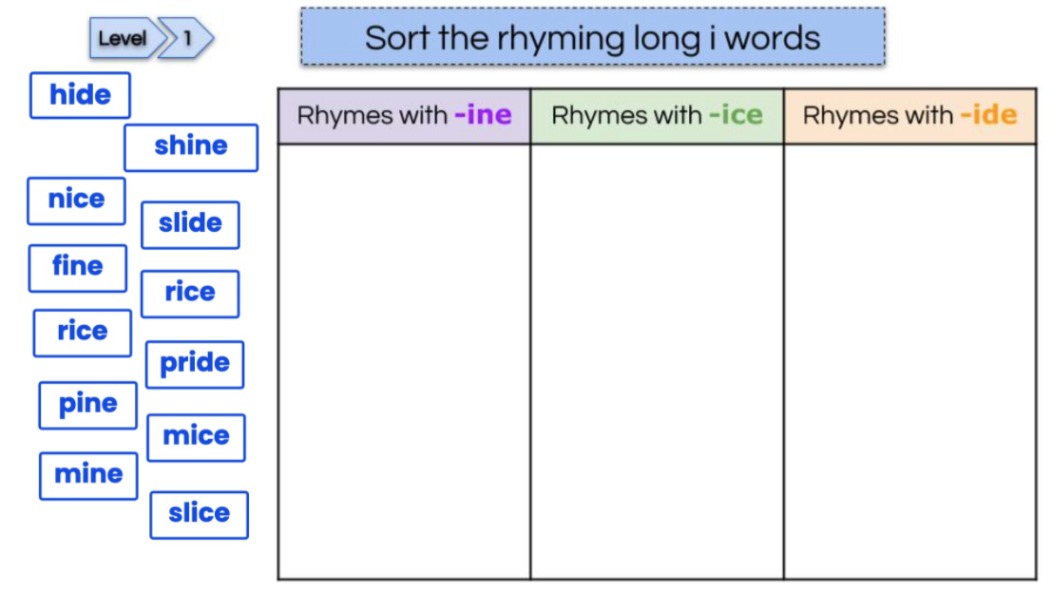 | Phonological Awareness  Focus - Syllables  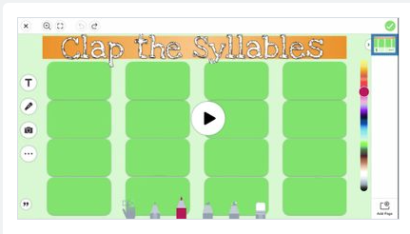 | Phonological Awareness  Focus - Onset and Rime  Refer to Seesaw for activity.  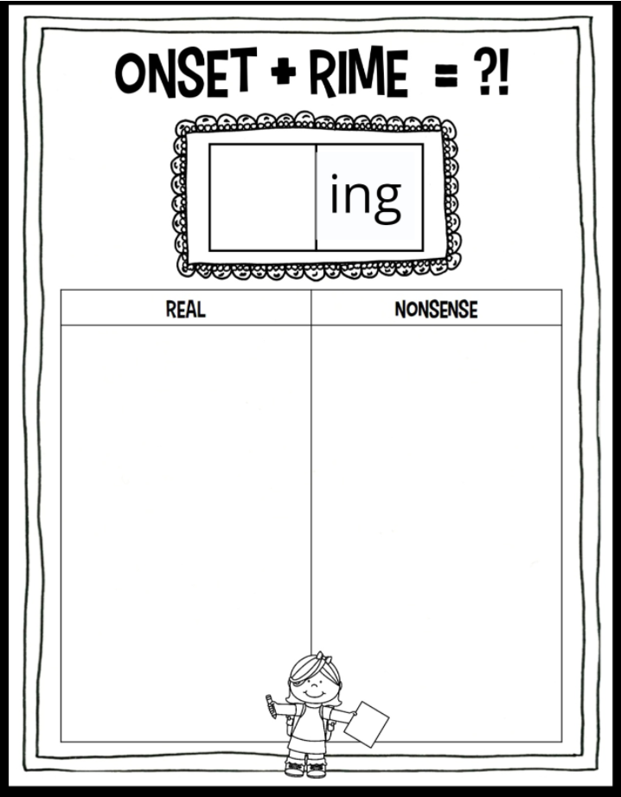  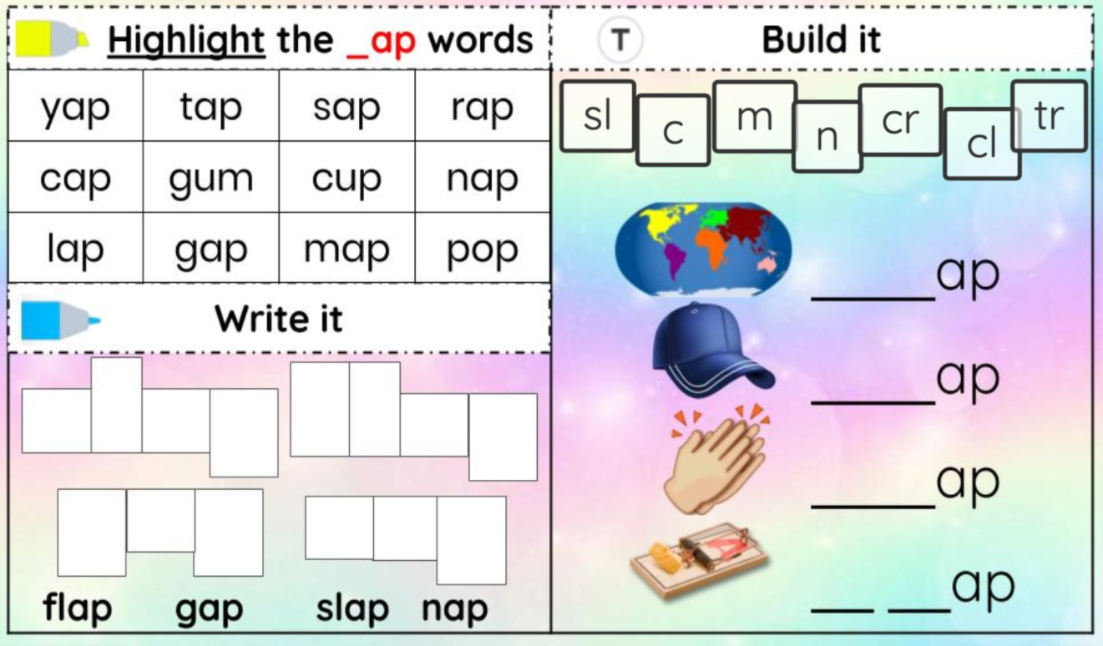
 |  | 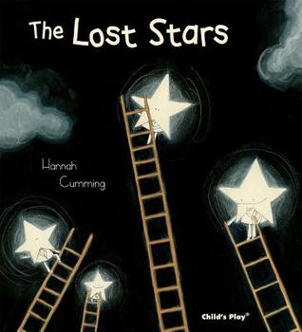 |  | Listen to Mrs Chueng read Ruby’s Worry | 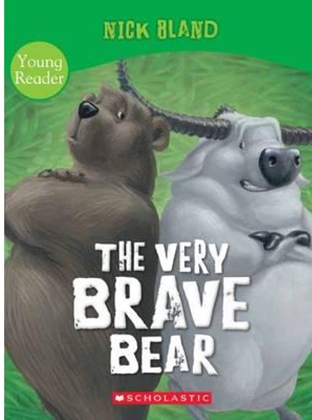  Listen to the book read by Mrs Karam
 | Writing (Planning) Imaginative text  Watch the Dinosaur Video  Plan an imaginative text (Complication and Resolution)  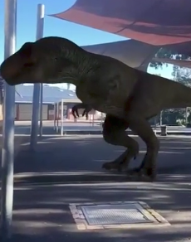 | Writing (Composing )Imaginative text  Dinosaur Video  Use your plan from yesterday to compose your complication and resolution of your imaginative text. | Writing ( Planning) Persuasive text  Persuade the audience why the pug should stay at LPS?  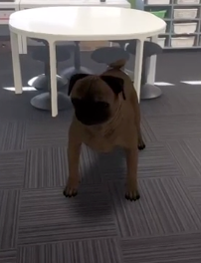 | Writing ( Composing) Persuasive text  Persuade the audience why the pug should stay at LPS? | Writing (Research a pug)  Title  Appearance,  Habitat  Diet (What does a pug eat?)  Interesting facts
Break
Reading with Mrs Evans
Middle | Mathematics  Warm Up:  Counting backwards by 5’s  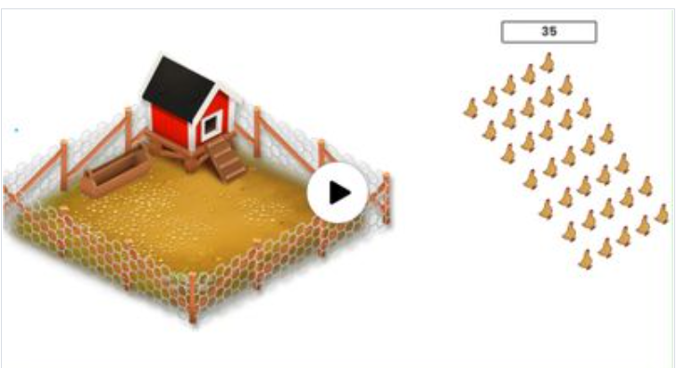  Year 1 - Bridging strategy  Watch the video posted on seesaw  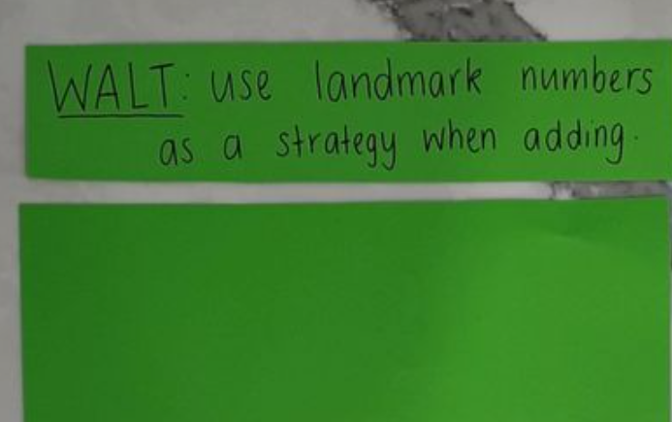  Complete the landmark activity on seesaw  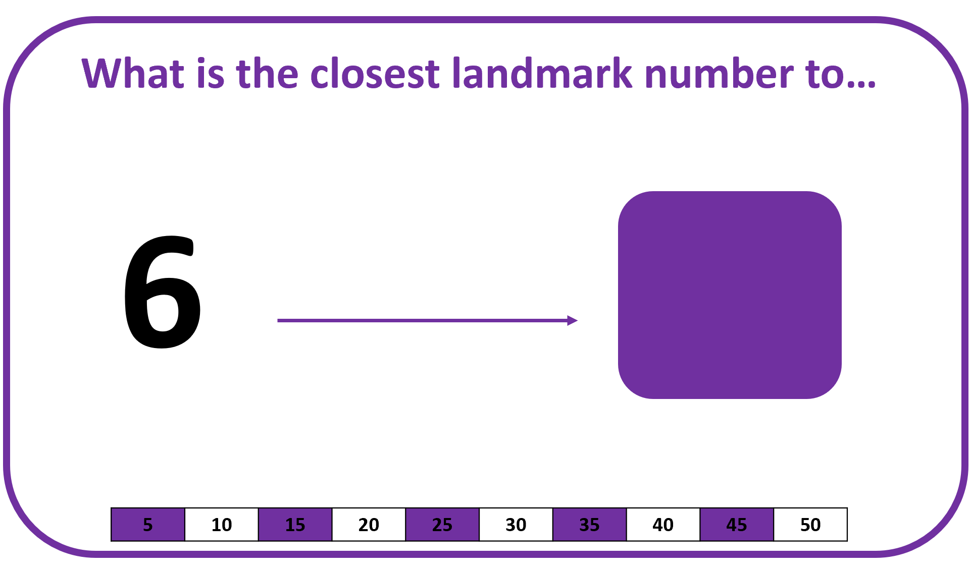  Year 2 - Jump strategy  Watch the video posted on seesaw  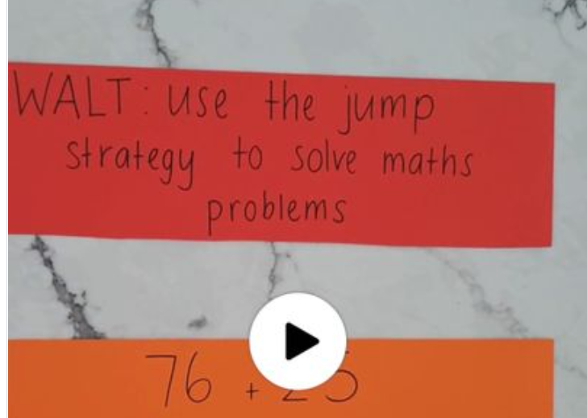  Complete the addition activity posted in seesaw  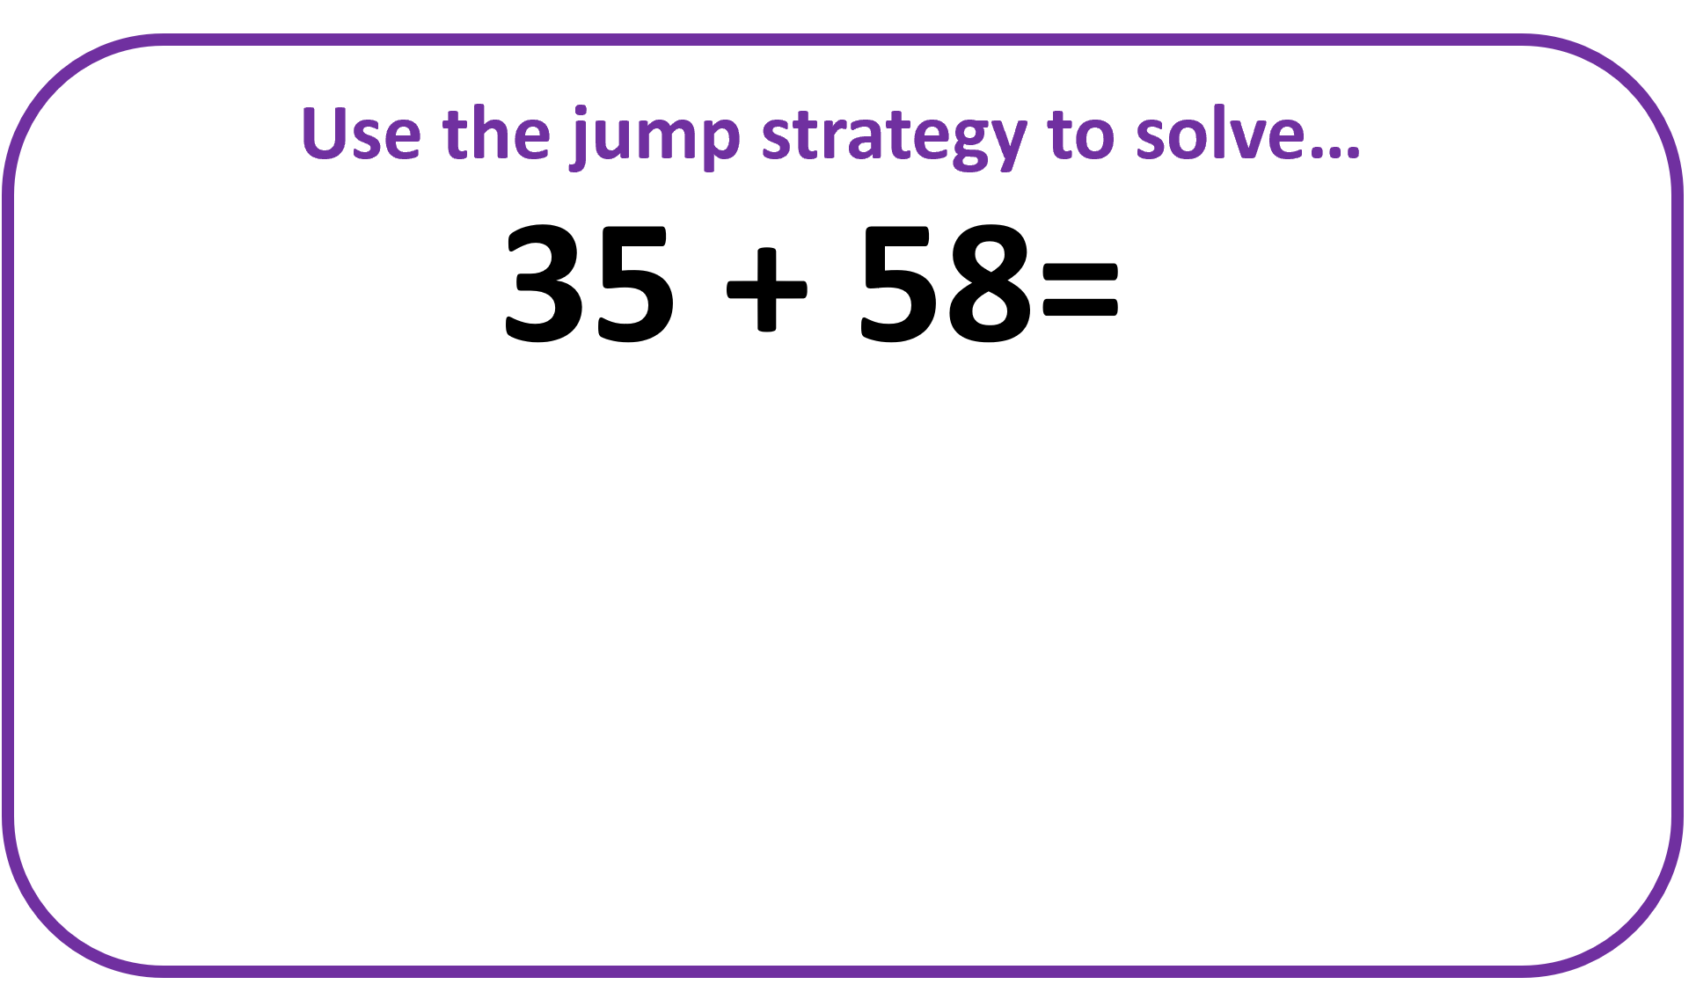 | Mathematics  Warm Up:  Counting backwards by 10’s  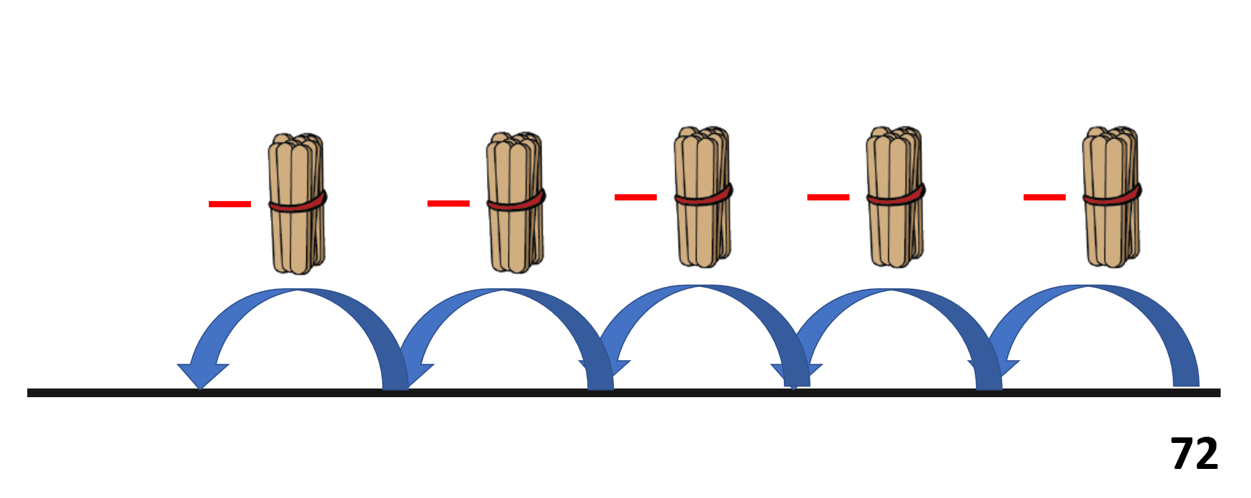  2D Shapes:  What shape am I?  Read the clues and circle the correct shape.  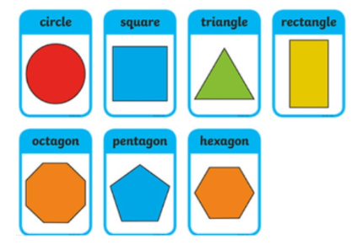 | Mathematics  Warm Up:  Counting backwards by 10s  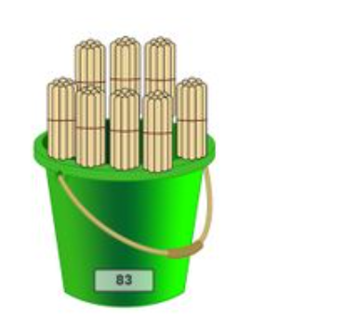  Addition and Subtraction  Year 1: Complete the four questions  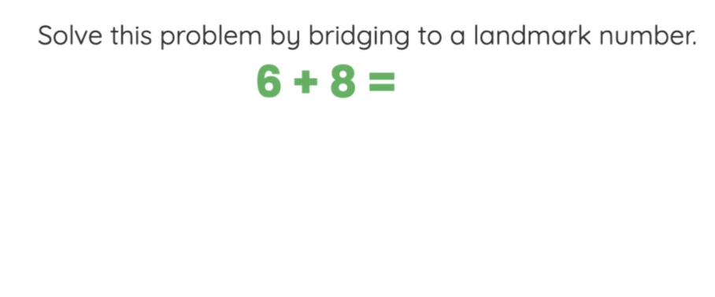  Year 2:  Complete the four questions  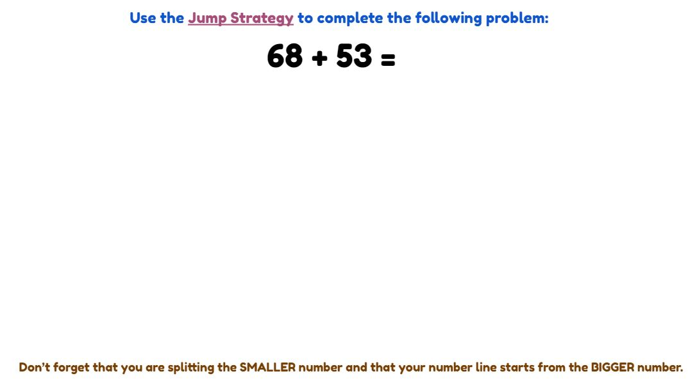 | Mathematics  Warm Up:  Record yourself counting backwards by 5’s from 100 and post it on seesaw.  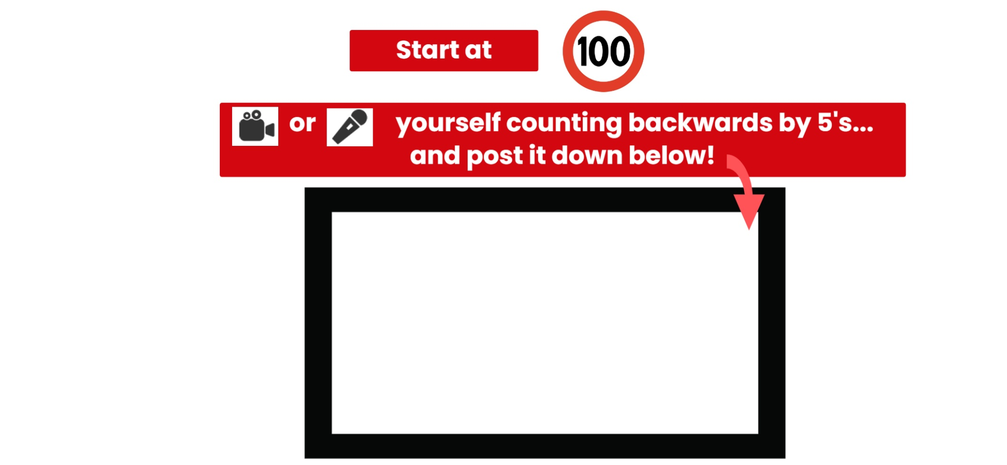  2D Shapes:  We are learning to identify the features of two dimensional shapes. Watch the video and complete the activities in Seesaw.  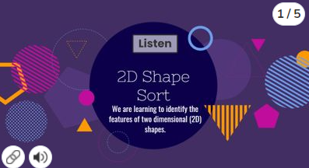 | Mathematics  Addition and Subtraction  Year 1: Complete the four questions  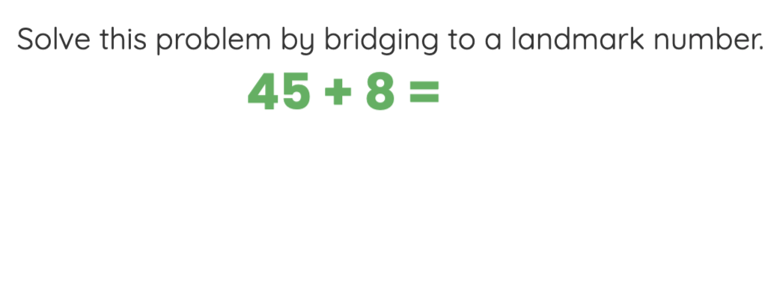  Year 2:  Complete the four questions  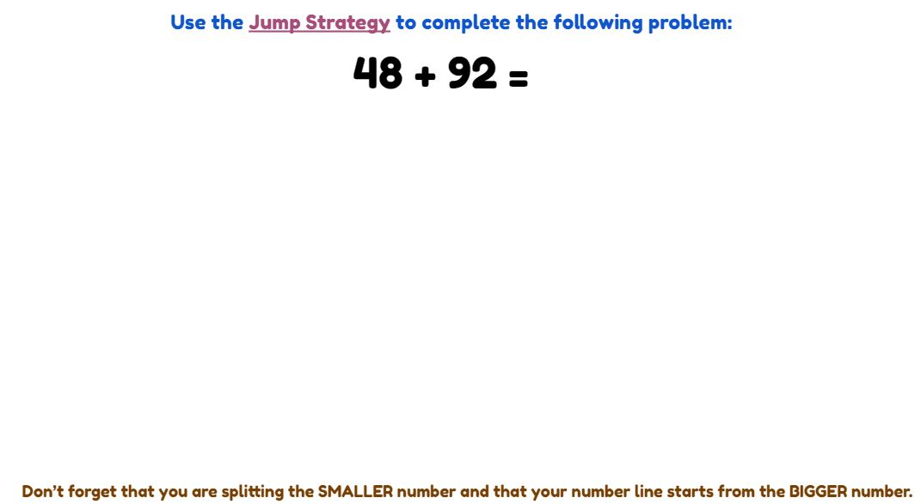
Break
Afternoon | Cultural Studies/RFF  Log onto your Seesaw and complete the activities set from your Cultural Studies or RFF teacher. | Science  Marvellous Mixtures. Today you will create your own mixture and explain its purpose. Log onto Seesaw and complete the activity set by your teacher. | Wellbeing Activity  Complete an activity from the new Wellbeing Activity Grid.  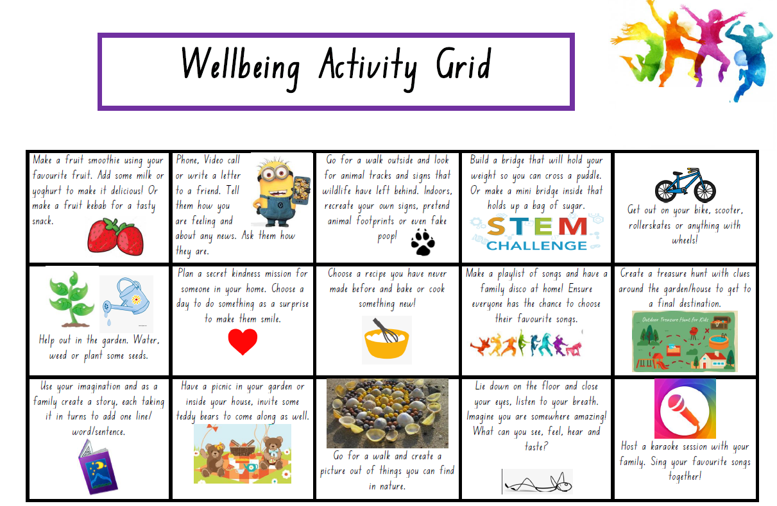 | Creative Arts  Create an artwork using as many 2D shapes as you can. You can use paper to cut the shapes or use items around your house.  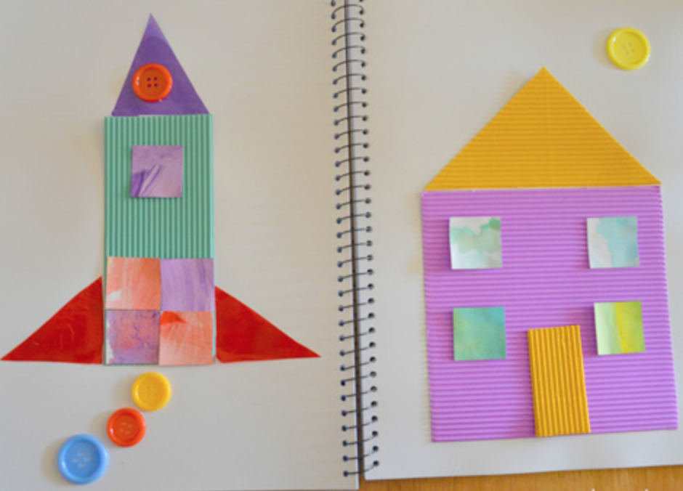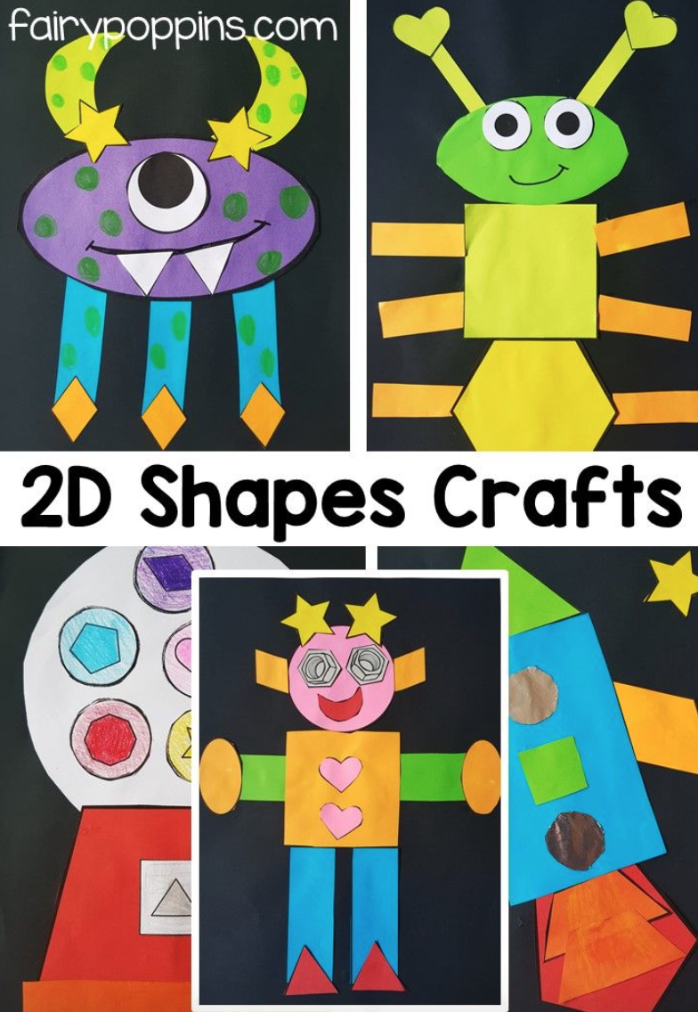 | Wellbeing Activity  Complete an activity from the new Wellbeing Activity Grid.

