Lansvale Public School

We’re excited about our return to face-to-face learning and welcoming students and staff back onsite where we know the best learning happens. This is a short summary of what our parents and students can expect.
While we know there is excitement about the return to school it’s important that we stick to the staged return to give us time to be ready to welcome back students onsite. Students will return to face-to-face learning in the following order
- from 18 October – department preschool, Kindergarten, Year 1
- from 25 October – all remaining year groups.
Our COVID-safe return to school plan is NSW Health approved and includes numerous effective practices to support the health and wellbeing of our students and staff. These practices include vaccinations, mask wearing, reduced mingling of student groups and staff, ventilation in classrooms and continued good hygiene and cleaning.
As we return to school students will be kept in their cohorts to minimise opportunities for transmission of COVID-19 and to enable effective contact tracing and containment. This means minimising interaction between students on school grounds and keeping cohorts together where possible.

Morning Drop Off
Students in K-6 can be dropped off in the morning from 8:30am and will be allocated separate playground areas as outlined in the table below. Please do not enter school grounds with your child/children in the morning.
If you child attends Before and After School Care you will need to enter the school grounds, from the Chancery Street gate, sign him/her in and leave the school grounds immediately.
Cohort | Morning Playground Area
Preschool | Drop off occurs between 9am – 9:30am at the Lansdowne Road gate. Staff will sign your child in at the gates and then take them to Preschool.
Kindergarten | Children will go to the Kindy Quad area
Year 1 and Year 2 | Children will go to the Awnings/Sails area
Year 3 and Year 4 | Children will go to the Oval
Year 5 and Year 6 | Children will go to the Basketball court and front of Year 5 and 6 classrooms
Afternoon Pick Up
The safest way to organise ‘Pick Up’ procedures at Lansvale Public School is to allow families onsite for a short duration. This will help to maximise social distancing by enabling families to spread out and will help to stop crowding and sprawling onto various roads around Lansvale Public School. Our school gates will be opened from 2:40pm as outlined below.
The preferred option for ‘Pick Up’ is utilising the ‘Kiss and Ride’ service located on Chancery Street. Parents are to remain in their car and our staff will assist children and families.
If you have more than one child at our school then it is expected that you will enter onsite (only if needed) at the time outlined below for the oldest child. For example if you have a child in Year 1 and in Year 4 you will enter onsite at the time outlined for Year 4 children.
Cohort | Afternoon Pick Up Organisation
Preschool | Pick up will occur between 2:30pm and 3pm. As parents arrive at the Lansdowne Road gate they will be greeted by a staff member who will collect children from Preschool and escort them to their family.
Kindergarten | Families will be able to enter onsite via the main gate entrance on Chancery Street from 2:40pm and meet their child in the Kindy Quad Area
Year 1 and Year 2 | Families will be able to enter onsite via the hall gate entrance on Chancery Street from 2:50pm and meet their child outside the hall
Year 3 and Year 4 | Families will be able to enter onsite via the main gate entrance on Chancery Street from 2:55pm and meet their child at the Awning/Sails area
Year 5 and Year 6 | Families will be able to enter onsite via the main gate entrance on Chancery Street from 3pm and meet their child at the Basketball Court
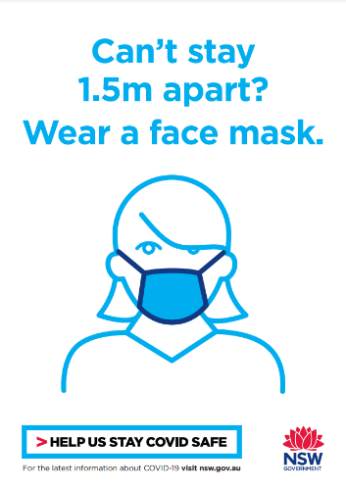
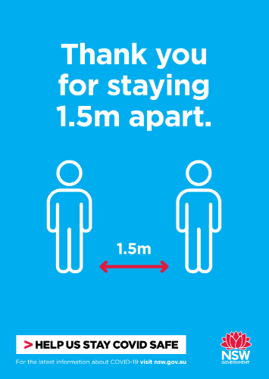
It is highly recommended that all families wear a mask whilst picking up their child. You will not be able to talk with your child’s class teacher at ‘Pick Up’ time. If you would like to speak with the class teacher, you will need to organise for a phone meeting. This can be organised by calling the school or messaging your child’s teacher on Seesaw.
Afternoon Pick up Map
The map below outlines the areas to meet children. You must follow the times outlined above.
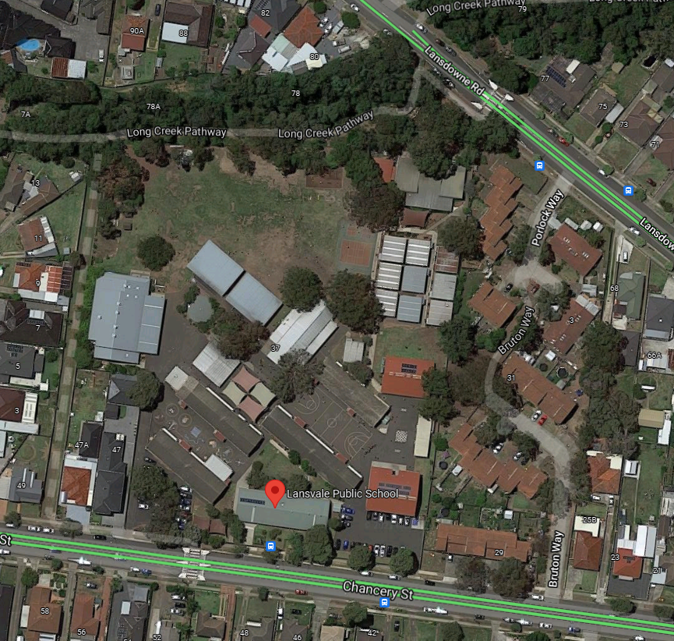
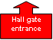
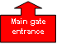
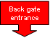
Yr 1 & Yr 2 pick-up area
Yr 3 & Yr 4 pick-up area
Kindy pick-up area
Yr 5 & Yr 6 pick-up area
Preschool pick-up area

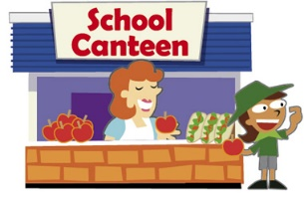
Canteen
Our school canteen will be in operation from Week 3. Children will be able to order their lunch and purchase items from the canteen; however, the children will be unable to ‘walk up’ and order items at recess and lunch.

The canteen has implemented a recess and lunch ordering system. This system will be supported by staff at Lansvale PS. Each class will be provided with paper bags for ordering and at 10am each day the recess and lunch orders will be collected from classes. The canteen will then process these orders and with support from Lansvale PS staff these orders will then be delivered to the classrooms.

Masks are required to be worn on school site by staff indoors and outdoors and strongly recommended for students indoors and outdoors unless exercising or eating.
All staff required on site supporting the return to school will need to be fully vaccinated from 18 October. Then from 8 November all staff, contractors, volunteers and students on student placement on a school site will need to be fully vaccinated, including Outside of School Hours Care staff.
I would like to reassure all members of our community that all staff onsite at Lansvale PS are double vaccinated.
Having open or well-ventilated spaces reduces the risk of transmission of COVID-19 because infectious particles are more quickly diffused in the open air. The department will continue to work with NSW Health to provide us with advice and guidance on maintaining good ventilation in our school and we will make use of our outdoor spaces wherever practical.
During Term 4 many school-based activities will remain on hold until NSW Health advise otherwise. This includes large celebrations like assemblies, presentation days and graduations, arts and sports events.
Parents and students will be notified if a decision is made to close the school due to a confirmed case of
COVID-19. During this time we will continue to provide learning from home activities and we will let you know when we can return to face-to-face learning.
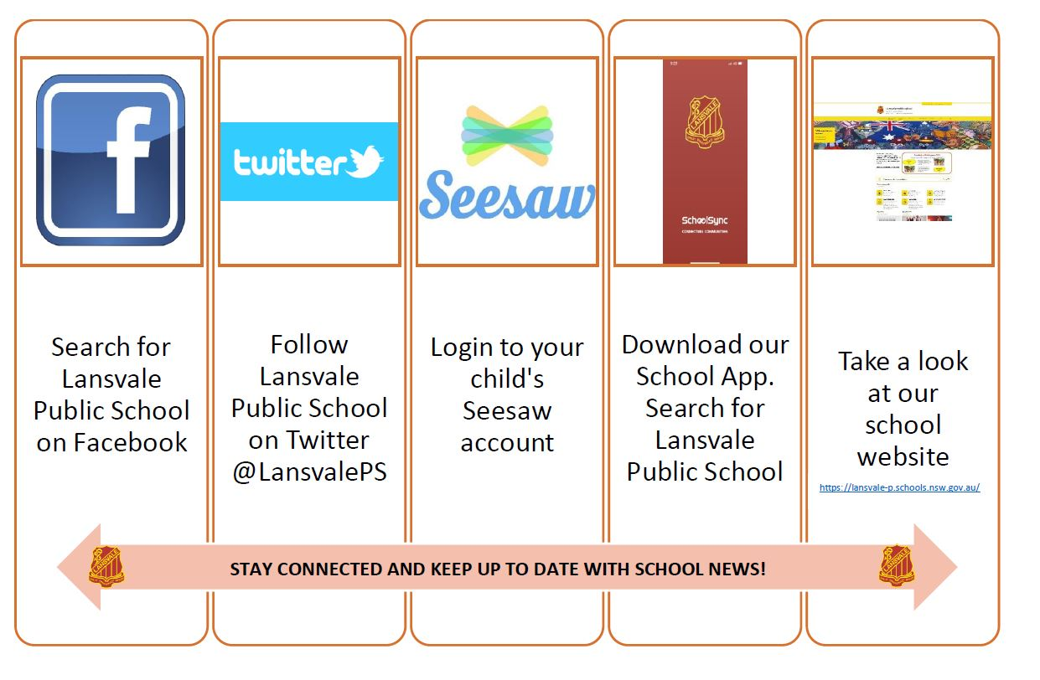
Please stay connected at Lansvale PS using the various communication tools as listed below.

Out of school hours care, vacation care settings and preschools operating on school sites will follow the same COVID-safe guidelines as public schools including the requirement to be fully vaccinated from 8 November.
Onsite orientations and transition programs are not currently allowed in person on school sites until we are advised differently by NSW Health. We’ll share more information in the coming weeks about our school’s virtual orientation and transition program.
From Mrs Karam
We will continue to review our Drop Off / Pick Up organisation and will make changes if necessary. Our focus is always on ensuring the safest organisation is in place. Thank you for your ongoing support. Stay safe!
If you have questions, please call our school on 9724 5252 or send an email to
https://www.lansvale-ps.nsw.edu.au/ and we will endeavour to get back to you as soon as possible.
I would like to take this opportunity to thank our staff, students and community for their understanding and support during this long period of Home Learning and welcome back to Term 4 with face-to-face learning. We look forward to seeing our Preschool, Kindergarten, Year 1 and Class 1/2V children onsite on Monday 18th October 2021.

Kind regards,
Mrs Laura Karam
R/Principal

